GROUP MEMBERS:HOPE JENNIFER EKEH 17/2417 58

ANYALECHI LAWRENCE 16/1406 20

AMENSILOLA AYODELE 17/2001 17

ADEFOWOKAN OLADIPO 16/0159 10

EMMANUEL GIFT 16/1046 50

JOHNSON OLUWAFERANMI DAVID 16/1228 70

IRIABE FAITH 17/0045 63

ADEMIDE ADEBIMPE 16/1688 6

DEPARTMENT: COMPUTER SCIENCE

INSTITUTION: BABCOCK UNIVERSITY

CITY/COUNTRY: OGUN STATE, NIGERIA.

EMAIL OF GROUP LEADER: hopejenniferekeh@gmail.com

**Web Based Traffic Calming System**

***ABSTRACT***

**In residential areas, lack of safety in transportation has become serious and with the help of expert systems that advices the road users the great need of putting on traffic calming schemes on the streets is been defined. Because in a country like Nigeria, we currently lack a structured background for the execution of traffic calming schemes. However, emerging an expert system can assist and advise engineers and road safety officers in dealing with traffic safety problems which will help reduce accidents and jams and in turn save lives. This expert system is been developed to give more information to the traffic safety experts, people who care about their lives and also see the need to help in these traffic calming measures which includes the decision makers, engineers, road safety officers and students. Planning to build the traffic calming system, resources and sources related to traffic calming studies as well as interviewing with domain experts will be done and the system developed will includes more than 100 rules and photos for diverse types of methods to be taken. The system will help in organizing traffic calming measures, prioritizing traffic calming strategies, and giving solutions for different traffic safety problems. In conclusion, some ignorant and illiterate street drivers may not check on this expert system talk more of adhering to it but verifications, making sure the processes are valid, and comparing the system with similar works carried out, it is known that the system is helpful and good enough for the residential street user.**

1. INTRODUCTION

Implementing traffic calming measures to deal with traffic and safety-related difficulties in residential areas requires knowledge and expertise that can be achieved from traffic calming handbooks and experts. This system is initiated on the idea that the residential roads are a means of relating people to their communities, presenting critical functionalities that help to create and reserve a sense of place. They offer service to the community as a whole and should effectively and safely serve multiple users such as walkers, tourists, runners, cyclists, children, shoppers and families, as well as motor-powered vehicle travelers and mass transport riders [6].

However, with the increase of urbanism and growth in the number of vehicles, urban streets and mostly residential streets have to deal with diverse traffic safety problems. Residential road users speeding through traffic, and other safety-related problems escalated the risk of accident between pedestrian and vehicles [6]. The main purpose of the traffic calming system is to decrease the rapidity of vehicles and the amount of nonlocal traffic capacity entering residential roads. Producing a background for executing traffic calming strategies can help both amateurs and knowledgeable engineers to distinguish problems and apply proper solutions where needed. The web-based expert systems can help spread information amongst engineers and other researchers because these systems can be retrieved anywhere and at any time with an internet connection with no installation needed.

1. REVIEW OF TWO CLOSELY RELATED WORKS
2. *De Souza work on Traffic Management System*

De Souza proposed a Traffic Management System based on V2V communication to diminish traffic cramming in highway surroundings that are caused by traffic accidents [4]. His proposed work gives storm problems present in data sharing in VANETs. It uses DRIFT protocol, which is a data broadcasting protocol for the freeway environments that works with various traffic problems and increases that data sharing capacity among the network partitions with little delays and little overhead [4]. The protocol shares accident warnings on the road. And when each vehicle driver gets a road warning, it changes its route if it is possible to get itself rid of the congested road, however reducing the time of the trip, fuel amount of fuel consumed and CO2 emitted. With this, the vehicles alerted when accidents occur also controlled the traffic congestion caused by traffic [4].

1. *Rakha and Kamalanathsharma Infrastructure-Based Traffic Management System*

They both presented an eco-driving model which depends on V21 communications that is constructed in traffic-light connections as a traffic light request for intelligent traffic lights (ITLs) [5]. The project lies more on improving the volume of fuel consumed and decreasing CO2 released by lessening the time that the vehicles spend stopping and staying at traffic lights[5].

However, each vehicle tends to adjust its speed to maintain the best fuel consumed and escapes delays at traffic lights. Through this, the eco-driving model directs data to the vehicles that are entering its reporting area and are getting to the traffic light, scheduling next phase and the length of vehicles’ queue at the connection, which is called the Signal Phasing and Timing (SPaT) [5]. With this information given, the vehicles puts quickly at optimum speed using the VT-Micro model that assesses the fuel consumption for substitute speed profiles and also decides which the best is [5]. With the employment of this, using the VT-Micro model, vehicles calculate instantaneously an optimum speed improving the amount of fuel consumed and lessening the discharge of CO2 to the surroundings [5].

1. DISCUSSION
2. *Problem statement*

The reason for this project is because of ignorant and nonchalant residential and highway road users who do not abide by traffic and road signs and rules thereby causing traffic and accidents on the streets, leading to congestions and discomfort to other road users. Increasing their transportation time, and over speeding which is the major safety problems in residential areas and highway environment [15]. However, this project will provide measures and better ways to reduce this congestion and discomfort on the streets and help reduce transportation time, over speeding which can make people lose their lives and help ignorant road users know more in the signs and rules guiding the roads while they run or drive through the streets [13].

b*. Objectives*

The aim of this project is to help adjust the speed limit of each vehicle driver and minimize vehicle traffic congestion thus reducing trip time and making the streets and better and safer place to transport [8].

The objectives are as follows:

* For drivers to come to understand and accept the need to limit their speed when driving through certain area.
* To detect areas with congested traffic.
* To provide a website that will educate the residential road on each road signs and how to implement them.
* To detect and tell road users on a traffic congested route.

c*. Methodologies*

However, in order to achieve this, we intend to deploy this expert system by making use of:

* A web framework named web2py, which is an open-source framework for agile or strong development of a secure database driven web applications. It is written in python and programmable in python. This web framework is a full-stack framework meaning, it contains everything required to develop a fully functional web application. For developing this expert system, IF-THEN rules would be used to show the knowledge base. In addition, over 50 rules would be generated. IF-THEN rules are suitable type of forward-chaining inference engine viewing where the decision starts from the data the users input and end with a particular goal [8]. Using an example, if the challenge X is true then solution Y would be the next option for the user. Also we would try to make the user interface of the expert system user-friendly so as to not confuse or easily frustrate the users when trying to find their problem and the required solution.
* Diagrams and pictures in relation to traffic rules and signs on the web page.
* Relationship diagrams.
* And Python libraries which include :

Experta, which is a python library for building expert systems,

PyCLIPS which is a module to interface Python and the CLIPS expert system shell and libraries,

PyKnow, and Pyke which is a form of logic programming which provides a knowledge-based inference engine. Pyke will help in code adaptability, reuse and performance of the code and it will direct the configuration and combination of the functions intended.

With this, drivers will come to understand and accept the need to limit their speed when driving through certain areas.

*d. Findings*

In my finding, traffic calming can have limited impact to average drivers’ speed, and its greatest impact is on reducing the speeding limits of those who travel in speeds greater than the expected which is the 85th percentile speed.

*e. The Algorithm of the system application.*

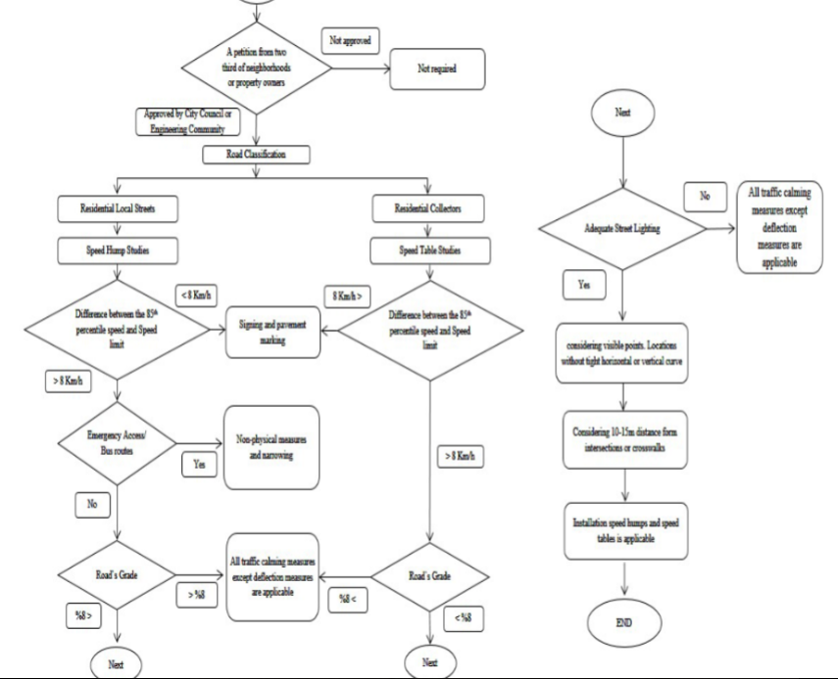

Figure 3.1 Flowchart/Algorithm for implementing the speed humps in the traffic calming system.

1. LIMITATIONS

* The maintenance cost of the system will be quite high because the traffic calming strategies embedded in the system has to be updated based on government policies.
* Some of the traffic calming strategies embedded in the system is going to affect emergency vehicles like fire trucks or ambulances.
* The knowledge these expert system is narrow because it is just focused on traffic calming strategies and nothing more.
* These expert system is only limited to performing abilities that is specific, relating to traffic calming expertise.
* This expert system is not good at managing highly sophisticated sensory inputs.

1. RECOMMENDATIONS

* Developing the algorithm for the area wise traffic calming scheme versus single street implementation.
* Increasing the role of road-users and neighbourhoods in implementation of traffic calming measures and the decision making process [10].
* Conducting more studies to determine the precise impact of traffic calming measures on traffic safety, speed reduction and volume reduction.
* Conducting studies towards the combination of the traffic calming measures and land-use management schemes such as shared pace and smart growth in order to improve the safety, and environmental issues in residential areas [10].
* Developing similar algorithms for streets with accident related problems and streets that suffer from lack of suitable infrastructure.
* Clean conducting of research to find the particular problem and how to handle it.
* Describing the situation: An important factor in evaluating traffic calming projects is the number of trips that are affected. The number of automobile trips affected is usually easy to determine since most communities have good motor vehicle traffic data. It may be more difficult to determine the number of non-motorized trips affected because they are usually undercounted.

Over speeding in residential streets are major safety problems in streets. Conventional traffic calming manuals often deal with just speeding through traffic, while traffic calming schemes handle wider ranges of traffic difficulties in residential roads. Safety procedures such as the complaint of non-motorized transport users, public conveyances, lack of infrastructure, and expansion factors are all absent in the decision making process of latest traffic calming manuals and rules [15].

1. SUMMARY/CONCLUSION

The implementation of the web-based traffic calming expert system will assist and advice engineers in dealing with traffic safety problems and also promoting awareness can increase knowledge of the situation which will drastically reduce the rate of fatal accident which occurs due to ignorance [10]. This expert system is developed for people who seek to implement traffic calming strategies including decision makers, engineers, and students by using physical design and other measures to improve safety for motorists, pedestrians. Improving transportation efficiency and reducing traffic congestion in both highway and residential areas is still and active and challenging research due to the criticality of transportation infrastructure been monitored by expert systems.

The main purpose of the traffic calming system is to reduce over speeding of drivers and the amount of traffic in residential areas and also to give routes of traffic free roads to the road users to reduce transportation time [6].

1. REFERENCES
2. J. Medina, and M. D. Ruiz-Lozano, J. L. Castro, M. Delgado, “An expert system for predicting object collisions. Its application for avoiding pedestrian accidents,” *Expert Systems with Applications,* Vol. 38, no.1, pp. 486-494, 2011. View at publisher. View at Google scholar. View at Scopus
3. R. Srinivasan, D. Harkey, and D. Tharpe, *Development of a Web-Based Expert System for Setting Speed Limits in Speed Zones,* Transportation Research Board, 2008.
4. F. Hayes-Roth, D. Waterman, and D. Lenat, “ An Overview of expert systems,” in *Building Expert Systems,* 1983. View at Google Scholar
5. De Souza AM, Yokoyama R, Boukerche A, et al, Icarus: improvement of traffic condition through an alerting and re-routing system. *Computer Network 2016*; 110:118-132
6. Rakha H and Kamalanathsharma R. Eco-driving at signalized intersections using v2i communication.*14th international IEEE conference on intelligent transportation system (ITSC),* Washington, DC. 2011
7. Amir Falamarzi, Muhamad Nazri Borhan, and Riza Atiq O.K. Rahmat Developing a web-based advisory Expert system for implementing Traffic Calming Strategies 2014.
8. Cooper, P. J. The relationship between behavior (as measured by violation conviction) and crash involvement *. Journal of Safety Research* , 1997. 28(2): 83-95.
9. Amir Falamarzi, Muhamad Nazri Borhan, and Riza Atiq O.K. Rahmat Developing an innovative algorithm for implementing vertical traffic calming meaures. 2016.
10. Highway, A. A. o. A. & T. Officials. 2011. A Policy on Geometric Design of Highways and Streets, 2011 Ed.: AASHTO.
11. DOWL. Traffic Calming Protocol Manual. Alaska, Municipality of Anchorage Traffic Department. 2001.
12. Ewing, R . Traffic Calming. State of the Practice Ed. Guegan, D. P., P. T. Martin & W. D Cottrell 2000*. Prioritizing traffic-calming projets using the analytic herarchy process. Transportation Research Record: Journal of the Transportation Research Board.* 1999
13. Johansson, C., P. Rosander & L. Ledan. Distance between speed bumps and pedestrian crossings: Does it matter? *Accident Analysis & Prevention* 43(5). 2011
14. Lithman, T. Traffic calming: Benefits, Costs and equity impacts Ed.: Victoria Transport Policy Institute Victoria, BC,, Canada. 1999
15. Malaysian Universities Transport Research Forum Conference 2013.
16. U.S. Department of Transportation*. Case Study No.19- Traffic Calming, Auto Restricted Zones and others Traffic Management Techniques* – Their Effects on Bicycling and pedestrians. Washington, D.C: Federal Highway Administration, 1994.
17. R. Elvik, T. Vaa, A. Erke, and M. Sorensen, *The handbook of Road Safety Measures,* 2009
18. O. F. O. R. Economic, *Speed Management*, 2006
19. A. Grana and M. Guerrieri, “Exploring effects of area-wide traffic calming measures on urban road sustainable safety,” *Journal of Sustainable Development,* vol. 3, no. 4, pp. 38-49,2010. View at Google Scholar
20. J. Paul Guyer, P.E., R.A. an Introduction to Highway Traffic Clming for Small Communities 2019
21. Transport and Environment Studies (TEST). Quality Streets- How Traditional Urban Centers Benefits Benefit from *Traffic Calming* London: TEST 1989.